**Research Methodology**

**CSS511**

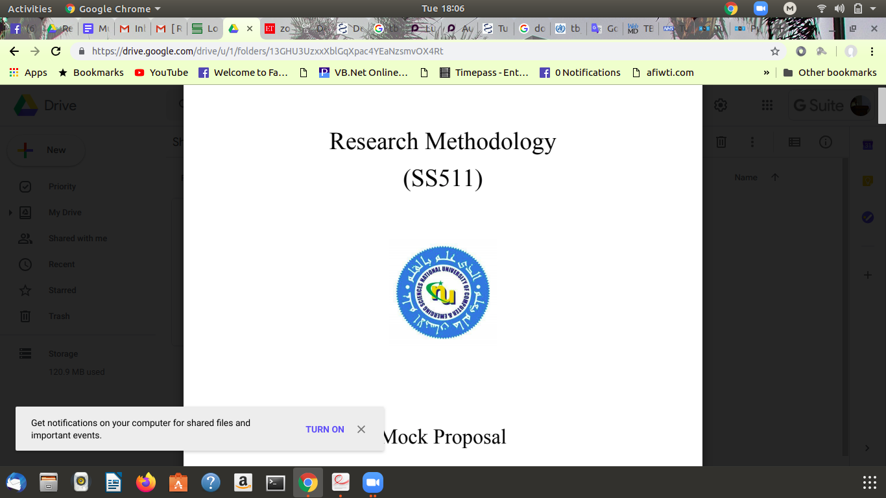

**Mock Proposal**

**Tuberculosis (TB) Diagnose with Patient Sound**

**Muhammad Qasim**

**Table of contents**

1. Introduction 03
2. Background 03
3. Research Background 03
4. Research Statement 04
5. Research Questions 04
6. Aims and objectives 04
7. Scope 04
8. Research Gap: 04
9. Research Methodology 04
10. Conceptual Framework 05
11. Expected Results 05
12. Discission 05
13. References 05

**Introduction:**

Artificial intelligence has a very important role to play in the world's fourth industrial revolution. A.I can help us to solve many of the world's problems very easily as you know that Tuberculosis (TB) is a type of lung disease. According to the World Health Organization (WHO), TB is a worldwide pandemic.it is among the top 10 killer infectious diseases, second only to HIV [1]. In Pakistan rural areas It takes a long time to diagnose this disease, because hospitals exist so far. In view of this problem, we want to create a mobile and web-based application that allows anyone to identify respiratory diseases with his or her voice whether he/she has a TB or not. Doctors can also use it to detect respiratory diseases at an early stage and efficiently suggest prescription by using this application.This will be a major revolution in the medical field.

**Background:**

Tuberculosis (TB) is one of the world's oldest deadly diseases. The main cause of TB is when the bacterium of the TB penetrates the human body through the respiratory tract, if its immune system is strong, then it eliminates the bacteria, causing the bacteria to damage its lungs.

Pulmonary TB is a bacterial infection of the lungs that can cause a range of symptoms, including chest pain, breathlessness, and severe coughing. Pulmonary TB can be life-threatening if a person does not receive treatment. Doctors treat patients with a long course of antibiotics. People with active TB usually begin to feel better after a few weeks of treatment.

**Research Background:**

There are several ways to test active TB.

1. Chest X-Ray most common test to identify TB.
2. Mantoux test: It involves injecting a small amount of a substance called PPD tuberculin into the skin of your forearm. It's also called the tuberculin skin test (TST)
3. Interferon gamma release assay (IGRA):The interferon gamma release assay (IGRA) is a blood test for TB that's becoming more widely available.

Some researchers have worked with patient sound frequency to classify TB with good accuracy. We can classify TB with patient coughing sounds may represent a viable low-cost and low-complexity screening method for TB.[2]

Auscultation of the lung is an important part of respiratory examination and it helps in diagnosing various respiratory disorders. Auscultation assesses airflow through the trachea-bronchial tree. It is important to distinguish normal respiratory sounds from abnormal ones for example crackles, wheezes, and pleural rub in order to make correct diagnosis[3] and chart improvement or otherwise.

**Research Statement:**

First we will try to apply binary classification deep learning techniques with simple ANN.

As we know that sound is frequency so we can plot on the X and Y axis. Neural networks always try to extract hidden patterns from input data and map with Label Y. so we will convert sound into an image then apply Convolutional Neural Network (CCN) for extracting more hidden patterns from input data.

**Research Questions:**

1. we will collect patients' cough datasets that have Active TB or Not Active TB from governments/private hospitals.
2. We will train our models on different classifiers like (ANN and CNN) Most highly Deep learning algorithms those many researchers are using nowadays.
3. We will use a kaggle dataset and also try to collect data from some government hospitals.

**Aims and objectives:**

Initially we will create prototype mobile or web-based applications or MVP. it will classify TB, Phenomena and respiratory diseases. With our mobile and web-based application every one can freely diagnose his/her diseases, Doctors can also use this application to identify patients' respiratory relevant diseases, prescription suggestions.

**Scope:**

This product will change village people's medical problems, it will predict respiratory diseases and also suggest prescription doctors can efficiently decide which medical drugs are best for this patient.

**Research Gap:**

Lots of ML practitioners apply different machine learning algorithms. We will try to improve accuracy. They have applied ML algorithms on X-Ray images or Sounds data, we try to apply Deep learning advanced algorithms on sound datasets because we have to detect TB at an early stage in the patient body for faster treatment.

**Research Methodology:**

We will try to collect data from different hospitals if they didn’t provide then we will train our model on kaggle datasets. Collecting sound samples TB active and Not active patients. Apply pre-processing techniques. Sound will be converted into image and image will be our model input. We will also try to improve generalization techniques to mitigate overfitting. Then deploy our model with a web-based application on any cloud platform using scale able application techniques.

**Conceptual Framework:**

We will use python, tensorflow 2.0, matplotlib, flask, docker, kubernetes and other techniques to complete this project.

**Expected Results:**

Currently ML researchers get max accuracy 0.8 we will try to improve more.

**Discission:**

This section I will write after completing my project when I will present this paper or project in any journal or conference.

**Conclusion:**

We are collecting data and trying to build our first prototype model using available data. I will present this statistics as soon as possible.

**References**

____________________________

[1] Tuberculosis: Current Situation, Challenges and Overview of its Control Programs in India

Gursimrat K Sandhu

J Glob Infect Dis. 2011 Apr-Jun; 3(2): 143–150. doi: 10.4103/0974-777X.81691

PMCID: PMC3125027

[2] Detection of tuberculosis by automatic cough sound analysis.

Botha GHR1, Theron G, Warren RM, Klopper M, Dheda K, van Helden PD, Niesler TR. Apr 2018

[3] Sarkar M, Madabhavi I, Niranjan N, Dogra M. Auscultation of the respiratory system. Annals of thoracic medicine. 2015 Jul;10(3):158. Available from: <https://www.ncbi.nlm.nih.gov/pmc/articles/PMC4518345/>

<https://www.physio-pedia.com/Auscultation>